August 9, 2010

IP Week Culminating Activity:
CPA Joins National Indigenous Peoples Assembly

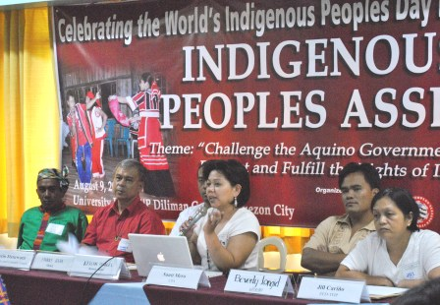
In this year’s celebration of the World’s Indigenous People’s Day, about 120 indigenous peoples from all over the country including the Cordillera Peoples Alliance, non government organizations, government agencies such as the National Commission on Indigenous Peoples and Commission on Human Rights, European Union and United Nations bodies, and indigenous people’s advocates gathered today at the University Hotel, UP Campus, Quezon City. The activity concludes the week-long celebration of IP Day which started with the submission of the IP Agenda to President Noynoy Aquino on August 5 in Malacanang, led by the Kalipunan ng mga Katutubong Mamamayan ng Pilipinas (KAMP) of which the CPA is a member.

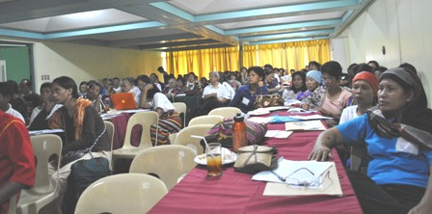
“Updates on the issues on land, development, climate change and indigenous knowledge systems, culture, peace and human rights in indigenous territories, and the policies and programs of government agencies and the European Union and United Nations bodies in the implementation of United Nations Declaration on the Rights of Indigenous Peoples in the Philippines were discussed in this activity,” said CPA Chairperson Windel Bolinget. Under the theme Challenge the Aquino Government to Protect, Respect and Fulfill the Rights of Indigenous Peoples, the assembly reviewed the Philippine indigenous peoples’ recommendations for the government’s implementation of the UNDRIP which IPs formed on August 2008. It was recalled that the Philippine government voted in favor of the adoption of the UNDRIP which the UN General Assembly finally adopted on September 13, 2007.

According to Bolinget, “Three years after the adoption of the UNDRIP, violations of indigenous peoples’ rights are intensifying which only shows the government’s insincerity in implementing the UNDRIP which sets the minimum standards to ensure the welfare, dignity and rights of IPs. In the Cordillera, these violations come in the form of heightened militarization and human rights violations, increasing mining applications and other forms of development aggression, and government neglect of basic social services.”

Bolinget further explained that this situation prompts the CPA, along with other indigenous people’s organizations in the country to demand “serious implementation of the UNDRIP by the government” on the occasion of IP Day. “By the end of the day, this assembly will submit a broader unified resolution on IP Agenda which will be presented to the IP Team of the Office of the President through Mr. Benjamin Abadiano and Pres. Noynoy’s sister, Ms. Viel Aquino-Dee, President and Treasurer of Assisi Foundation respectively. The IP Agenda contains the demands of IPs for the respect and recognition of their collective rights as IPs. We are putting this forward with the hope that Pres. Noynoy Aquino will listen to our voices,” said Bolinget.

Along with the said IP Agenda, CPA also submitted Dr. Constancio “Chandu” Claver’s open letter to President Noynoy Aquino which challenges Pres. Aquino to keep his promises to the Filipino people, stop extrajudicial killings and enforced disappearances and prosecute the perpetrators and their coddlers, and release political prisoners. Chandu’s wife, Alyce Claver, fell victim of extrajudicial killings on July 31, 2006.

The activity is jointly organized by the national indigenous women’s network – BAI, Cordillera Peoples Alliance, KAMP, Tebtebba, and EED Task Force on Indigenous Peoples. A symbolic action of unity for the indigenous people’s “Commitment to pursue our struggle towards the realization of our inherent right to land and self determination in all forms and levels” capped the activity. # CPA Public Information Commission

